Session 15 – GRC Wei Cui

**Lab Objectives**

1. Follow the instructions for Project 15-3: Using an Internet Port Scanner.
2. Write a report including screenshots and written descriptions. Be sure to include a screenshot and description for step 10.

**Lab Results**

1. Went to [www.grc.com](http://www.grc.com) as shown in Fig. 1.
2. Pointed to Services and then clicked ShieldsUp. It led to Fig 2.

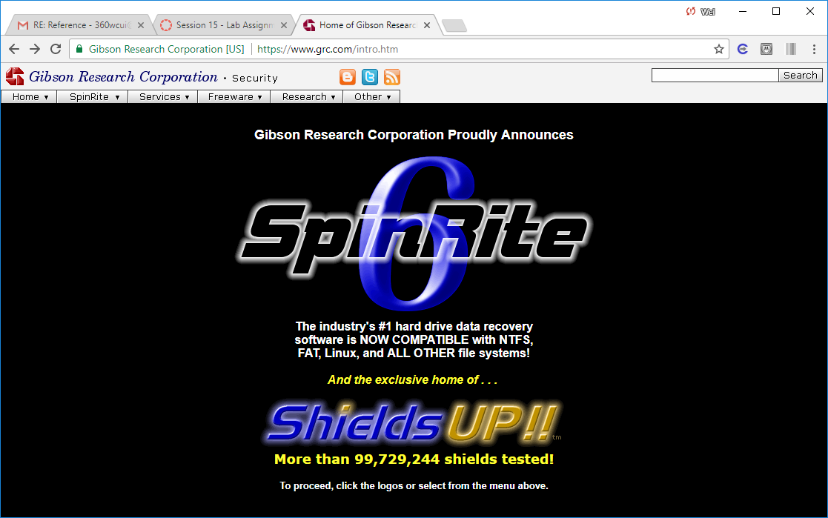

Fig. 1 Home page of www.grc.com

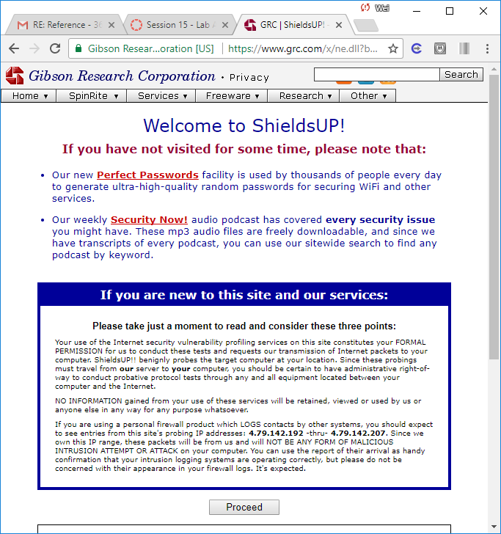

Fig. 2 Services page

1. Clicked the Proceed button
2. Clicked the All Services Ports button to scan ports on my computer as highlighted in Fig. 3. Grid is displayed indicating which ports are open (red), closed(blue), or blocked (green). When the scan completes, scroll through the report to view the results. Then printed the report as shown in Fig. 4.

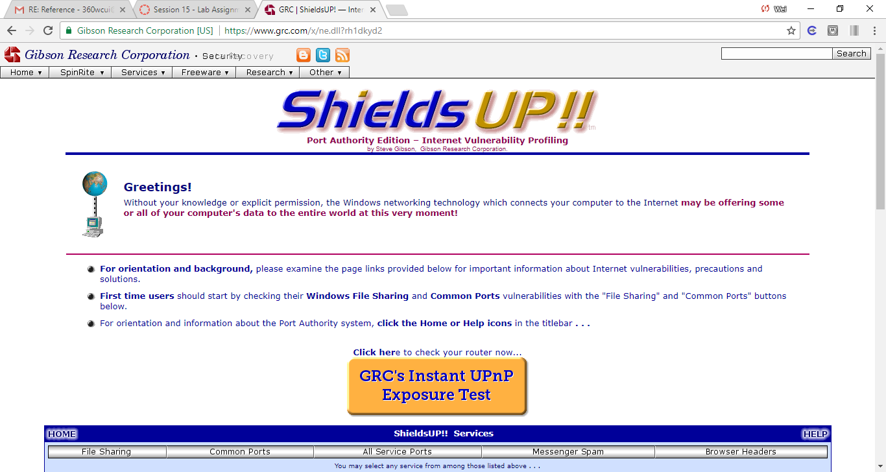

Fig. 3. Shield Services. All Service Ports button is highlighted.

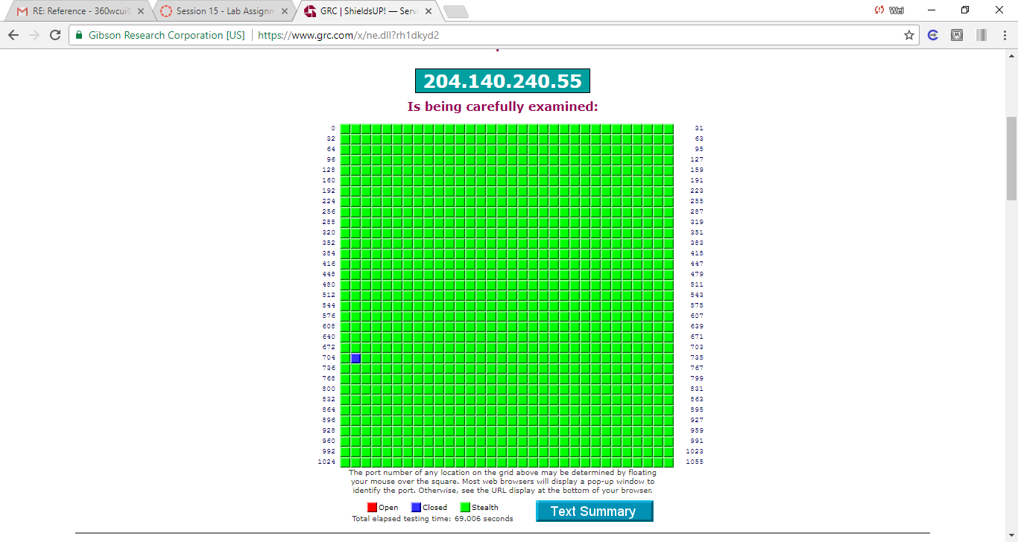

Fig. 4. Grid is displayed indicating which ports are open (red), closed(blue), or blocked (green).

1. Scrolled down the clicked the File Sharing button. ShieldsUP! Probed my computer to identify basic security vulnerabilities. Print this page when finished as seen in Fig. 5. Shields UP! attempted to contact the Hidden Internet Server within my PC, but preliminary Internet connection got refused! Either this system has closed this usually-open port, or some equipment or software such as a "firewall" is preventing external connection and has firmly closed the dangerous port 139 to all passersby. It was unable to connect with NetBIOS to my computer.

All attempts to get any information from your computer have failed. Relative to vulnerabilities from Windows networking, this computer appears to be very secure since it is not exposing any of its internal NetBIOS networking protocol over the Internet.

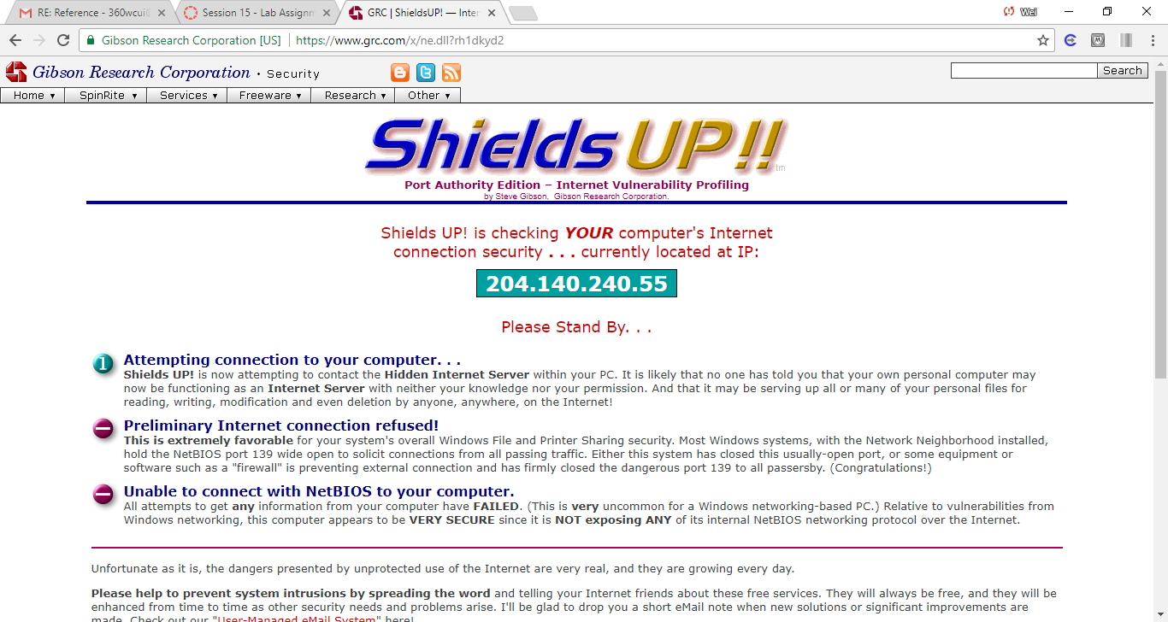

Fig. 5 Some basic security vulnerabilities identified. The finding is my computer very secure.

1. Closing or blocking open ports can be done through either the router or firewall to which the computer is attached or through the software firewall running on the computer. To access the windows firewall settings to change the configuration of the ports go to Control Panel, then clicked System and Security, then Windows Firewall. However, my computer has McAFee installed which blocks all the firewall settings as shown in Fig. 6

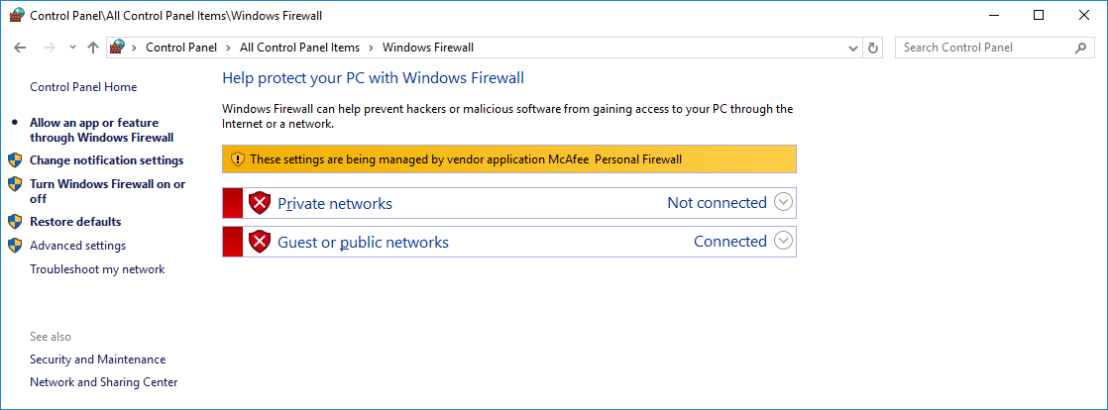

Fig. 6 The settings of the firewall has been disabled by McAfee installed on my laptop